**First we will review, leave feedback, and approve Part 1 (a teacher cannot move on to Part 2 until this happens)**

From the “SLO Approval” tab in MyPGS, click on the teacher’s name. Teachers with a green check mark in a section have had that section approved.

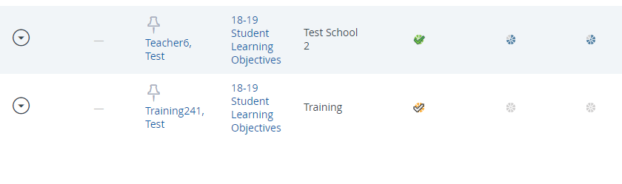

Now click on the section waiting for approval (yellow check mark).

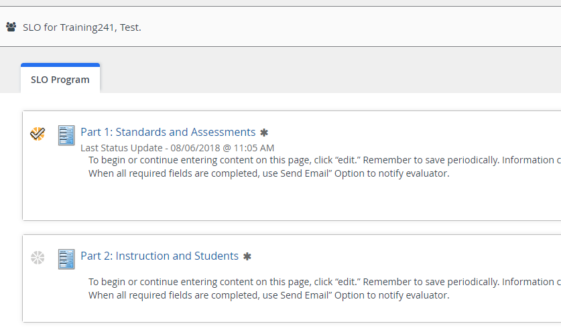

On this page you can read through the teacher’s SLO. At the bottom of the page, you will leave feedback and approve Part 1.

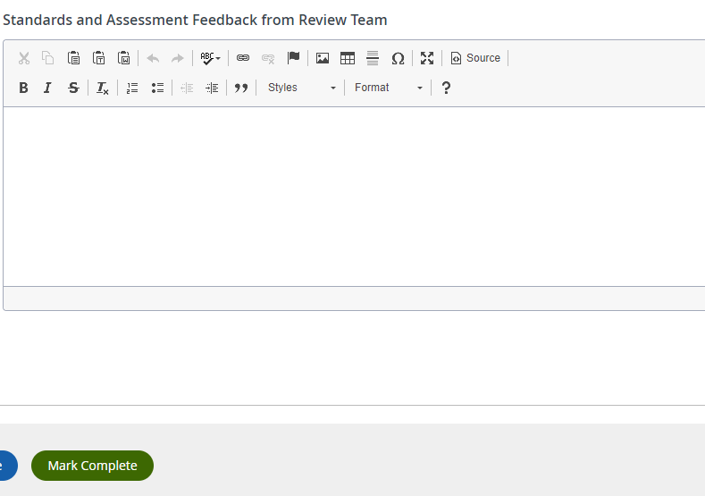

The Administrator clicks Mark Complete which enables the teacher to move on to Part 2

The SLO Review Team leaves feedback here

Now there is a green check mark for Part 1

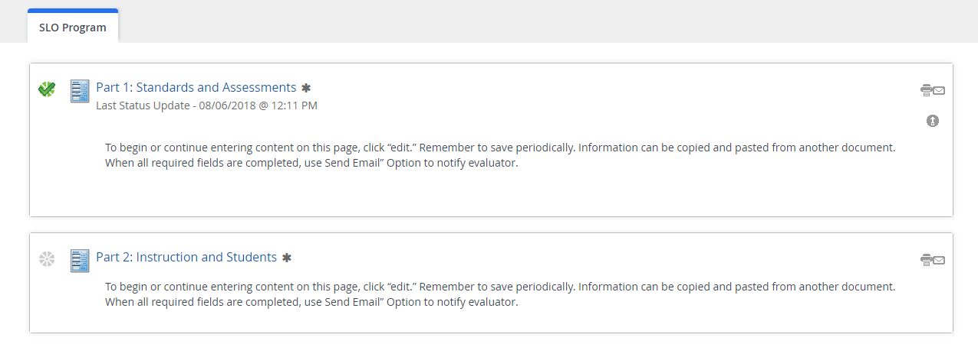

Now let’s review and approve Part 2. There is no check mark here because the administrator approval step is required.



Before we look at Part 2, let’s look at the student data sheet.

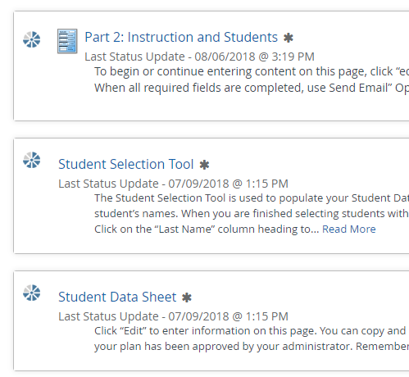

Here we can see where students are starting and where the teacher projects them to end relative to standards mastery. Remember to consider the contexts of the assessment and the standards when reviewing this data. For example, growth in writing often takes longer than growth in mathematics so we could anticipate higher targets in math.

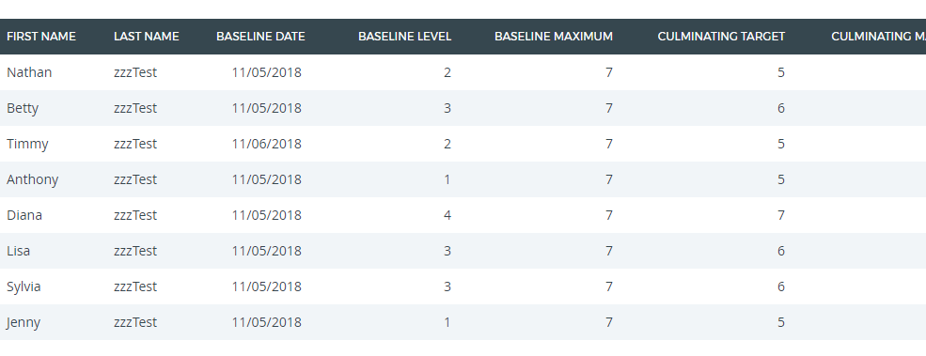

After reviewing the student data sheet, click on “Part 2 Instruction and Students” this page you can read through the rest of teacher’s SLO. At the bottom of the page, you will leave feedback and approve the section.

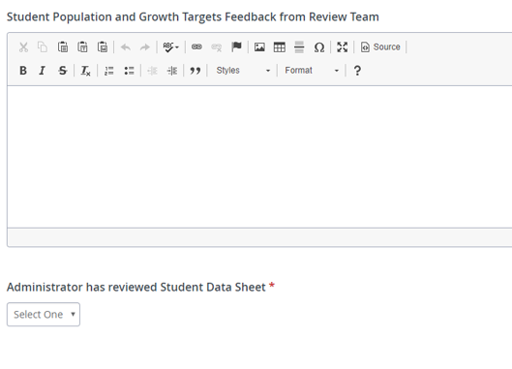

The Administrator signs off that s/he has reviewed the student data sheet (during the Review Team process)

The SLO Review Team leaves feedback here

This teacher is now ready to implement. At the end of the instructional interval, s/he will input culminating student scores and answer some reflection questions which you will see in the Results Phase Sign Off step ☺